Development of Soil Suitability Ratings Index for Crops in the North – East of Libya Using Geographic Information System
Bashir A. Nwer* | Abdulmeanem M. Whaida | Fatima M. Grab

University of Tripoli - Faculty of Agriculture - Department of Soil and Water

bash.nwer@gmail.com

Abstract

Agriculture production faces a great challenge for the coming decades which is the food security for the ever-increasing world’s populations. The key role in sustainable agriculture production can be played by sustainable soil uses and management. Land evaluation for specific purpose is an important tool for land use planning. A number of land evaluation techniques have been developed to assess land for different uses. The parametric approach is one that combines various soil and site properties (parameters) that are believed to influence yield using mathematical formula.

Keywords: Land- Crops- Suitability- GIS- Food security- Land use- Sustainability.

Introduction

The food supply should be granted to 6 billion inhabitants on 2000 and estimated 8 billion people in 2025. Food supply shortages occurs in arid and semi-arid zones where a land degradation and desertification are the main obstacles facing sustainable agriculture. A determination on how to use best the lands in the North-East of Libya for sustainable agriculture and environmental protection is prerequisite. These predictions are then used to guide strategic land use decision making (Rossiter, 1996; Van Diepen et al., 1991; Nwer, 2005).

The Study Area

Location

The study area is located in the strip of the coastal territory and Jabal Akhdar Upland bounded by the following coordinate’s lat 31° 30 – 33° 00’N; long 19°50‐ 22° 45’E. This area of the country is known as North East and includes the Benghazi region and the Jabal Akhdar highlands Figure (1).
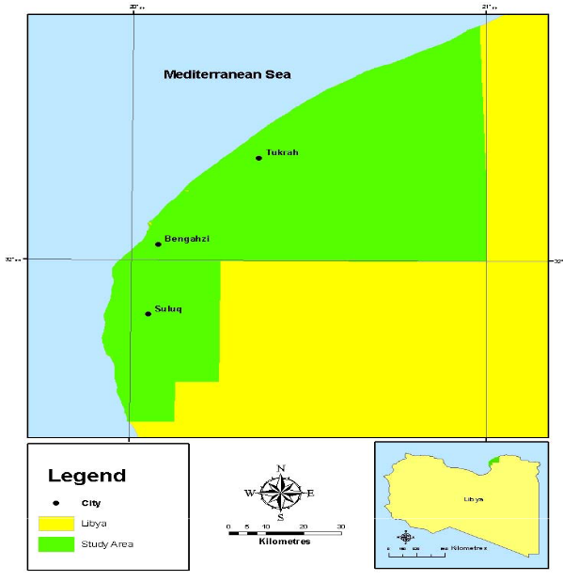
Figure (1) The location of the study area

Climate

The study area is situated in a Mediterranean type climate, in the belt of subtropical alternate atmospheric circulation. In the summer the climate is determined by a stable high-pressure zone situated over the Mediterranean Sea, i.e., by the Azores maximum spur with descending tropical air currents.

Material and Methods

Soil Productivity Index

The productivity index rating which has been developed by Mahmoud (1995) was applied to produce a productivity rating index in as follows:

The results are calculated to produce suitability classes Table (1). …………………….
………………………………………………………….
…………………………………………………………….
Table (1) Productivity rating and suitability classes

Productivity rating % | Classes
0-20 | Not suitable
20-40 | Marginally suitable
40-60 | Moderately suitable
60-80 | Highly Suitable
80-100 | Very High Suitable
(Source: Ben Mahmoud, 1995)

Results and Discussion

Soil Productivity Ratings for selected Crops

The soil productivity was conducted to wheat, barley, wheat, maize, and sorghum. Six maps were produced and area calculation for each suitability class were preformed Figure (4) to Figure (9).

Figure (4) % Soil Productivity Rating Index classes for Barley

Conclusion

There is no doubt that computer systems and GIS allow land evaluation to be performed more efficiently; they limit the margin for human error, and save time and cost. In addition, the added value of such systems is that different scenario can be run and thematic output can be produced accordingly.

References

Davidson, D.A. (2002) The Assessment of Land Resources: Achievements and New Challenges. Australian Geographical Studies, 40, 109‐128..

Martin, D., & Saha, S. (2009). Land evaluation by integrating remote sensing and GIS for cropping system analysis in a watershed. Current Science, 96(4), 569-575.

Nwer B (2005) The application of land evaluation technique in the north-east of Libya, Ph.D. dissertation, Faculty of Environment., Cranfield Univ., Silsoe, 2005.

Rossiter, D.G. & van Wambeke, A.R. (1989) ALES version 2.2. Userʹs Manual. Department of Agronomy, Conrnell University, Ithaca, New York.

تطوير مؤشر تقديري لدرجة ملائمة التربة لإنتاج المحاصيل فى شمال شرق ليبيا باستخدام نظم المعلومات الجغرافية
بشير أحمد نوير* ، عبدالمنعم محمد اوحيدة ، فاطمة محمد القراب
جامعة طرابلس - كلية الزراعة - قسم التربة والمياه

bash.nwer@gmail.com

الملخص
يواجه الإنتاج الزراعى تحدي كبير في العقدين القادمين يتمثل في الأمن الغذائي لسكان عالم يتزايدون بشكل مضطرد. لذلك يمكن ان تلعب إدارة استعمال التربة لانتاج المحاصيل بشكل مستدام دورا رئيسيا في التنمية الزراعية المستدامة. لذلك فأن تقييم الاراضي يمكن ان يكون أداة مهمة لتخطيط استعمال الاراضي، وقد تم تطوير عدد كبير من التقنيات والطرق والمناهج لتقييم الاراضي لعدد من الاستخدامات. وتعتبرالطريقة العددية إحدى هذه الطرق لتقييم الاراضي، وهي تلك الطريقة التي تأخذ في الاعتبار عدد من خصائص التربة والموقع (مؤشرات) والتي يعتقد بانها ذات تأثير على إنتاج المحاصيل باستخدام و تطويرمعادلات رياضية مبسطة.

الكلمات المفتاحية: الاراضي – المحاصيل – الامن الغذائي – استعمال الاراضي- الاستدامة.

